  - Community Support Home
Program

Foster Care Program

Métis Child & Family Services Society (MCFS) are seeking compassionate, caring individuals to provide a home for our children and youth.

- Foster families are provided with ongoing training and support through Métis Child & Family Services to enable them to provide the best care possible.

- Support group meetings enable our foster families to share their strength, wisdom, knowledge and experiences with each other.

Métis Child and Family Services Society (MCFS) Edmonton provides support for Children and youth who are in the care of Albert Child and Youth Services.

Criteria for Becoming a Foster Care Family:

- Application(s) must be at least 18 years of age.

- All members within the applicant(s) family home must be interested.

- Applicant(s) should be emotionally, financially and physically stable.

- Applicant(s) must be willing to encourage and support contact between and child and his/her natural family.

- Applicant(s) must be comfortable with the Aboriginal community and child’s family members

- Applicant(s) must be willing to invest time into Orientation Caregivers training and Mandatory training.

- Applicant(s) residence must be licensed by the Child and Youth Licensing Unit.

Métis Child and Family
Jiggers

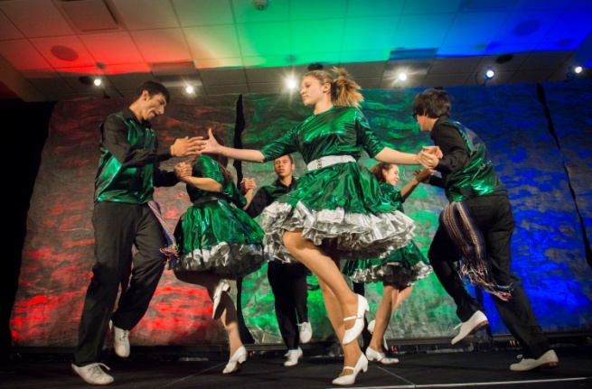

For Bookings Call

Florence Gaucher, Manager
(780) 452-6100 ext 227

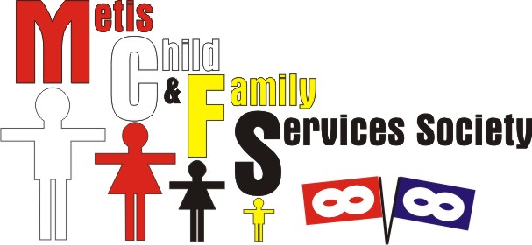

10437 – 123 Street
Edmonton, Alberta
T5N 1N8

Ph: (780) 452-6100
Fx: (780) 452-8944

Website:

www.metischild.com

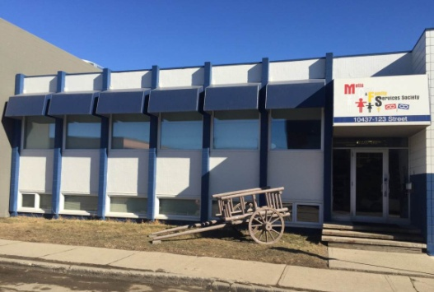

Mission Statement

To promote the health and well-being of our Métis children and families by building on the capacity of our Métis community through the provision of culturally sensitive and appropriate programs and services.

Agency Objectives

- To improve the quality and effectiveness of social services to Aboriginal Children and families in need.

- To develop and provide programs which will preserve and strengthen the Aboriginal families

- To develop community awareness and responsibility for the wellbeing of Aboriginal children and families

A primary focus of Metis Child & Family Services Society is to reduce the number of Metis and other Aboriginal children from coming into the care of Alberta Child and Youth Services

We accomplish this by ensuring that our programs and services are responsive and accountable to the community. We offer an alternate approach to intervention and prevention that is holistic and family centered.

Agency Support Programs

FRN-Aboriginal Child and Family Support Program
Is a program, which supports families and youth with present or past involvement with Alberta Child and Youth Services. Services offered are advocacy, in-home support, youth work, informal counseling and community referral supports.

Aboriginal Family Services
Is a preventative program for children, youth and/or families, who aren’t involved with Alberta Child and Youth Services, struggling with issues such as parent-child conflict and grief and loss. Services offered are advocacy, in-home support, youth work, informal counseling and community referral supports.

Family Violence Program

A program that assists individuals with exiting an abusive situation and/or work on a safety plan to maintain a healthy and safe environment. Services that are offered are advocacy, in-home support, informal counseling and community referral supports.

Justice program

An Indigenous focused program for youth and families needing support and advocacy when involved with the legal system or Alberta Children Services. Services offered are advocacy, legal direction, and one-on-one support.

Health For Two

A program that promotes and assists in maintaining healthy pregnancies as well as the initial two months post natal health. Services offered are prenatal education resources and community resources.

Choices Youth Program

The Choices program focuses on youth who are at risk of dropping out of school. This program is delivered at multiple schools throughout the city of Edmonton. Activities include life-skills, workshops, teaching coping skills, talking circles, recreational, cultural, and craft activities as well as informal counseling.

Community Follow up Program (PSECA)
A program in collaboration with Alberta Child and Youth Services working with children and youth identified in a high risk and sexually exploited situation. Services offered are ongoing support, advocacy, youth work, informal counseling and community referrals supports.

Kinship Care Program

This program connects children in care with extended family or other significant individuals in their life. Closely follows services provided and requirements of our foster care program.

Seniors Support Program
The objective for the Aboriginal Senior program will be to reach seniors that are being missed due to various situations and barriers to access the services, programs that are available to them in the community. Our mission will be to improve the quality of life for our seniors with a Preventative approach program that is focused on needs of Aboriginal Seniors.

